
In this page you will find some guidelines about how to write effectively and how to improve your writing.

- The writing process: presentation

Use this presentation each time you want to remember how to organize your ideas in the process of writing a text.

- Guide to Grammar and Writing
- Writing for EFL
- Mispelled words Game
- Spell Check Game: "SpellaRoo"
- Writing techniques
- Expresión escrita
- Personal pronouns: Subject prononouns, Object pronouns
- Conjunctions
- Prepositions
- Spelling rules
- Subject-verb agreement
- Revising your work before the final version.

THE WRITING PROCESS
- Brainstorming:
Example of a brainstorming design:
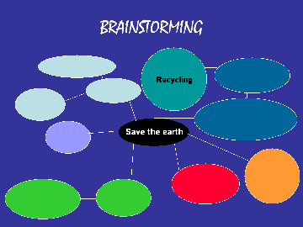
This graph serves to explain an easy way to generate ideas. You write down the ideas that come up to your mind. One idea usually takes you to another idea until you get a map like the one above.
You then select the main idea around which is related to most of them. The main idea is connected to subtopics which are also related to other ideas. You can group similar ideas in subtopics. In this way, you get a map of ideas that can be very useful to organize your ideas and your paragraphs.
You can use other graphics to organize your ideas depending on the type of writing. See these graphics

- Remember to organize your ideas in an outline that is usually divided in three sections:
OUTLINE
1. INTRODUCTION
- State your idea
2. BODY
- Develop ideas
- Support ideas with arguments
3. CONCLUSION
- Reemphasize, summarize main idea
These are the things you ALWAYS have to check in your composition when revising it:
REWRITING TIPS
After you have written your first draft you need to revise your work. Here you have some suggestions:
- Check subject-verb agreement in every sentence.
- Check spelling rules, capital letters and punctuation.
- Check word-order in the sentence; remember "every sentence MUST have a subject" and the adjective usually precedes the noun.
- Check tense coherence: for instance if you are talking in the present check that verbs are formed correctly in their present form. Check adding -s, -ed, -ing, etc.
- Check adjectives: Remember that adjectives have no plural in English.
- Is your text well organised?
- Do you have a clear introduction and conclusion?
- You can also exchange your composition with your partner. He/she should tell you what is not clear in your text. Listen to his/her suggestions.
- Reread your paper. Make your corrections ("rewriting tips" above) and make the changes or revisions that your partner suggested.
- Rewrite the final draft.

http://www.uhu.es/antonia.dominguez/avi/writing_guide.htm

